# Pimcore Interface and Features:-

## How to create a class in pimcore:

In order to create a class in pimcore interface following are the steps:

* Login to pimcore interface and go to settings ->Object->Classes then click on classes as shown in the screenshot

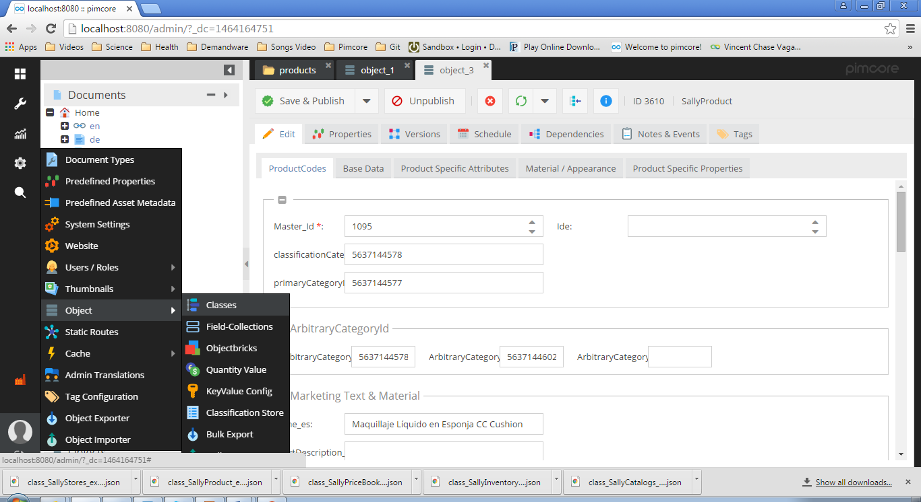

* On the right side you will be prompted with the following screen

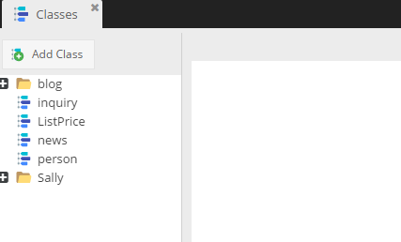

* Then click on Add Class button after that enter the “name” for your class then click on ok button. Now your class will be shown under classes section.

## How to import a class definition in pimcore:

* Select the class in pimcore on which you want to import an existing class definition for example as shown in the screen

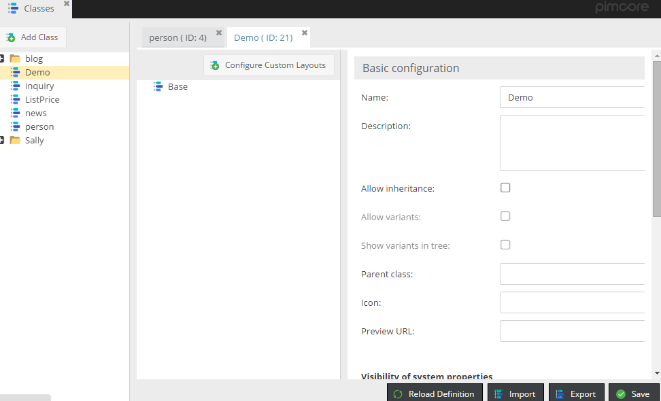

* As shown in the screenshot “Demo” class is have been currently selected .In order to select a class just click once on the class you want to select from the available classes.
* Now to import an existing class definition click on the import button shown as in the screenshot in the right bottom side.
* Now select a class definition file with .json extension then click on upload button.
* Now click on save button. Now you will be able to see the attributes defined in your .json class definition that you imported.

## How to export a class defined in pimcore:

* Simply click on export button as shown in the Class Import Example defined above. Now your class will be saved with .json extension in your download folder.

## How to import a csv file in pimcore:

* To import a csv file you must have a class defined in pimcore with attributes defined as according to column names in csv and follow these steps
* Login to pimcore then click on Objects menu below Assets menu after doing so you will get a screen as shown in the screenshot.

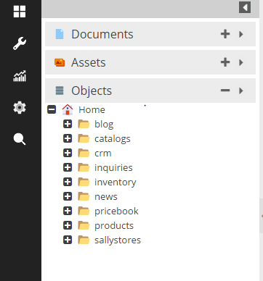

* Now right click on Home and click on Add Folder and give it a name under which all your imported data from csv will be saved.
* Now right click on your newly created folder under Home then select CSV Import after that just select and click on the class whose data you want to import then choose the csv file and click on upload button as shown in the screenshot.

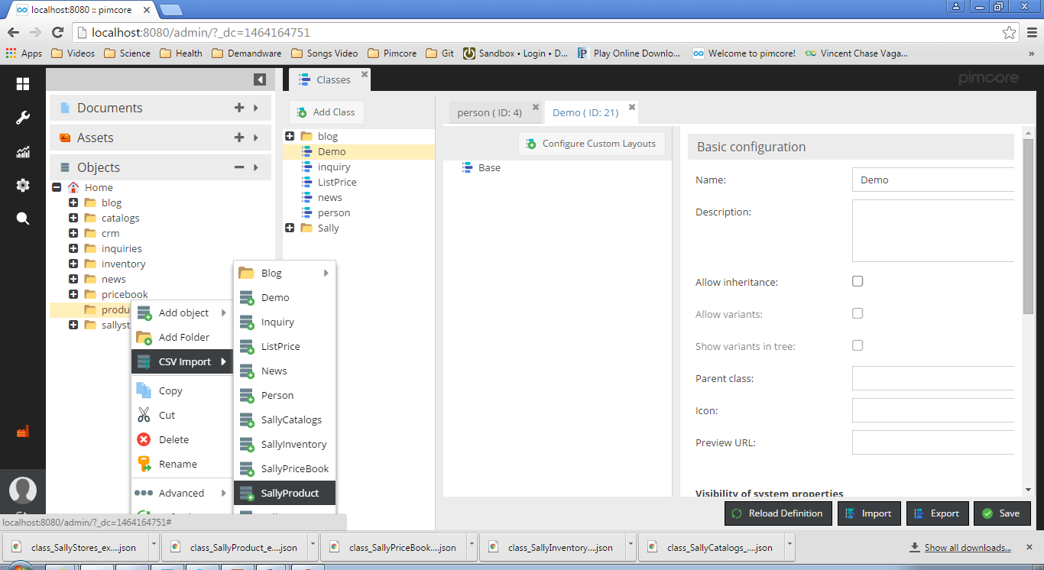

* After doing the above step you will be prompted with the follow data mapping as shown in the screenshot.

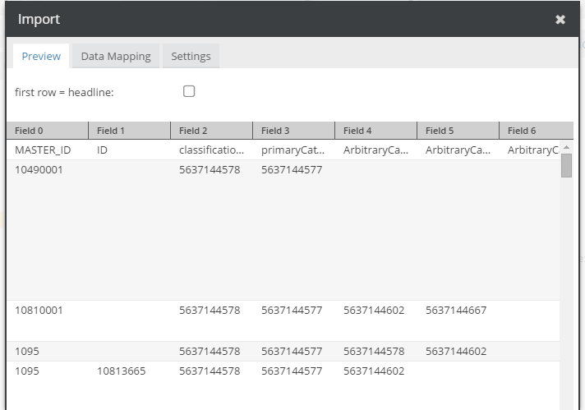

* Just tick the first row=headline checkbox if first row of your csv are exactly as class attributes name otherwise the first row will be treated as object as all other line going to be in the csv
* Now click on the Data Mapping tab under this tab it will be shown to you that which attribute from csv will be matched to what attribute of the class in pimcore .Just check all attributes mapped to their right targets attributes otherwise you can change by selecting any attribute under targets tab.
* Now click on settings tab then click on import button in the bottom right corner of the Prompted screen as shown in the screenshot.

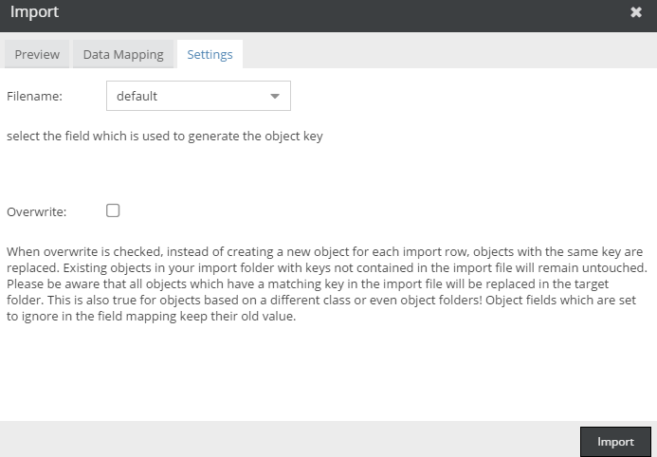

* Now each row of csv will be shown as a single object in pimcore under your folder as shown in the screenshot.

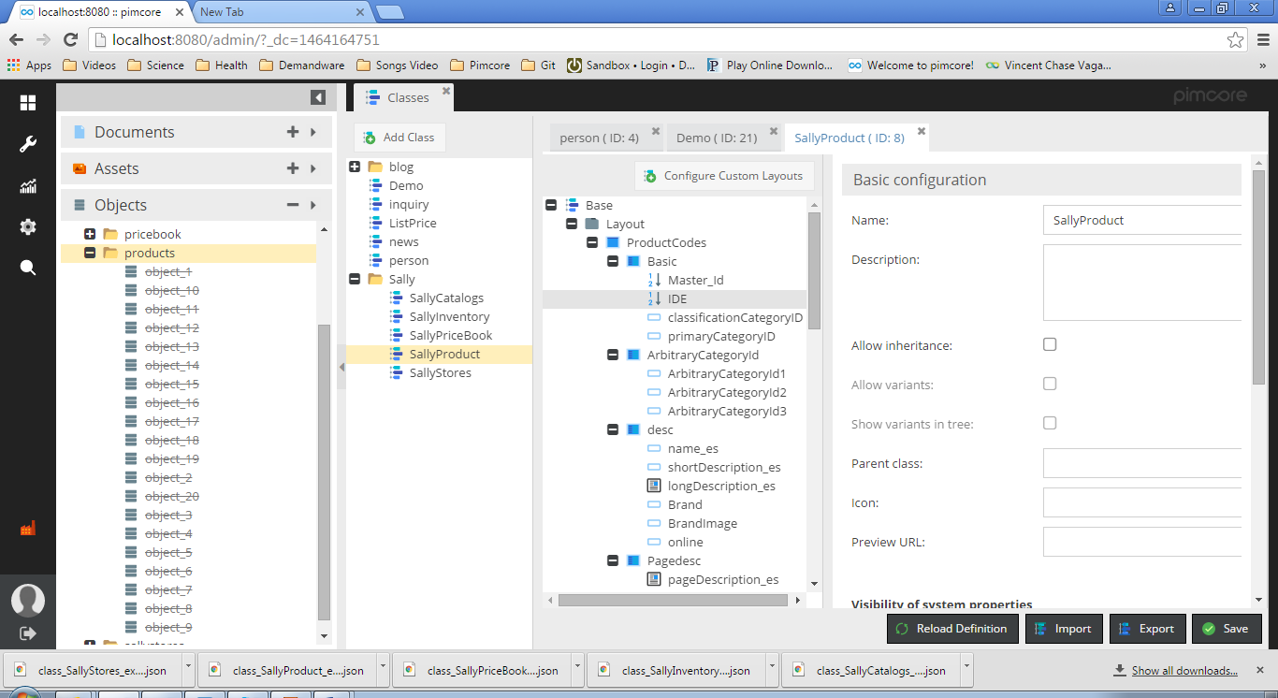

## How to run scripts in pimcore:-

### This method is defined to be working with Xampp only

* To run script go to the following directory C:\xampp\htdocs\pimcore\pimcore\cli under this directory you can place the php file containing your code that you want to run
* For Example If you have a file named SallyInventory.php then to run it open Xampp Control Panel and click on shell shown in right side then using command you have to type

**Cd htdocs\pimcore**

**php pimcore\cli\ SallyInventory.php**

* If your code is generating any Xml file or any other file then it will be saved under htdocs\pimcore\yourFileName directory.

### For Files that have been attached with this document.

* Put all php files under C:\xampp\htdocs\pimcore\pimcore\cli and then run these files using Xampp Shell Command Prompt.
* Generated Xml Files will be saved under C:\xampp\htdocs\pimcore with the file name as for example “SallyInventoryExport_25-05-2016-12-54-28.xml”.